**Setup:**

* **We need Visual Studio 2013 or later version to execute the Tests.**
* **Download and Install the Visual Studio 2013 (**if it’s not installed**).**
* **Copy the zip file of the project into local drive of the machine.**

**Prerequisites:**

**Execution:**

* **To open the project using Visual Studio follow the navigation below.**

**Go to File 🡪 right click 🡪Open🡪Project/solution🡪 A pop-up window appears asking for the saved project (in the local) to be opened 🡪 Click on the Microsoft Visual Studio Solution🡪Click on Open.**

**Step 1:**

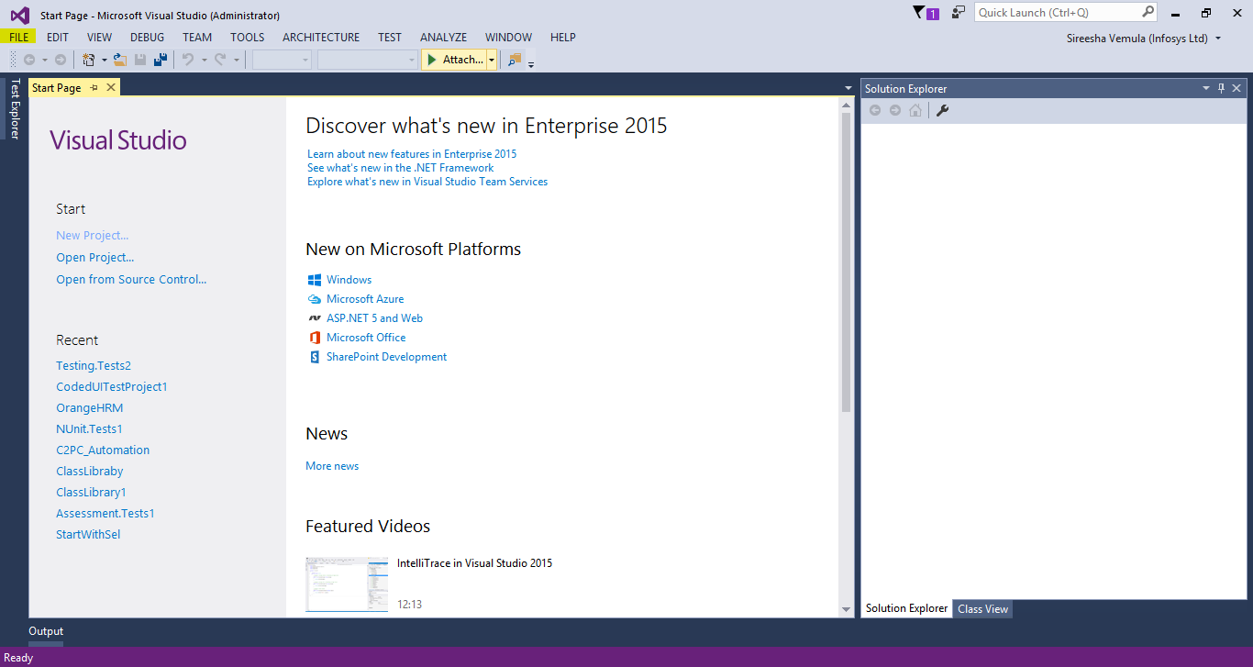

**Step 2:**

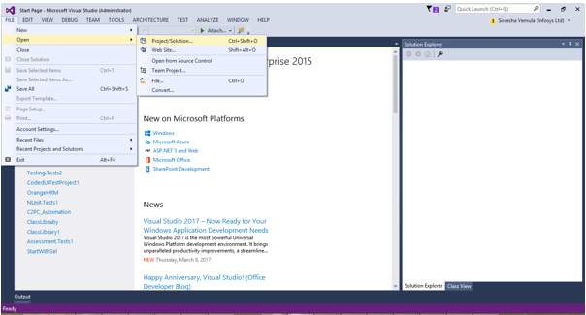

**Step 3:**

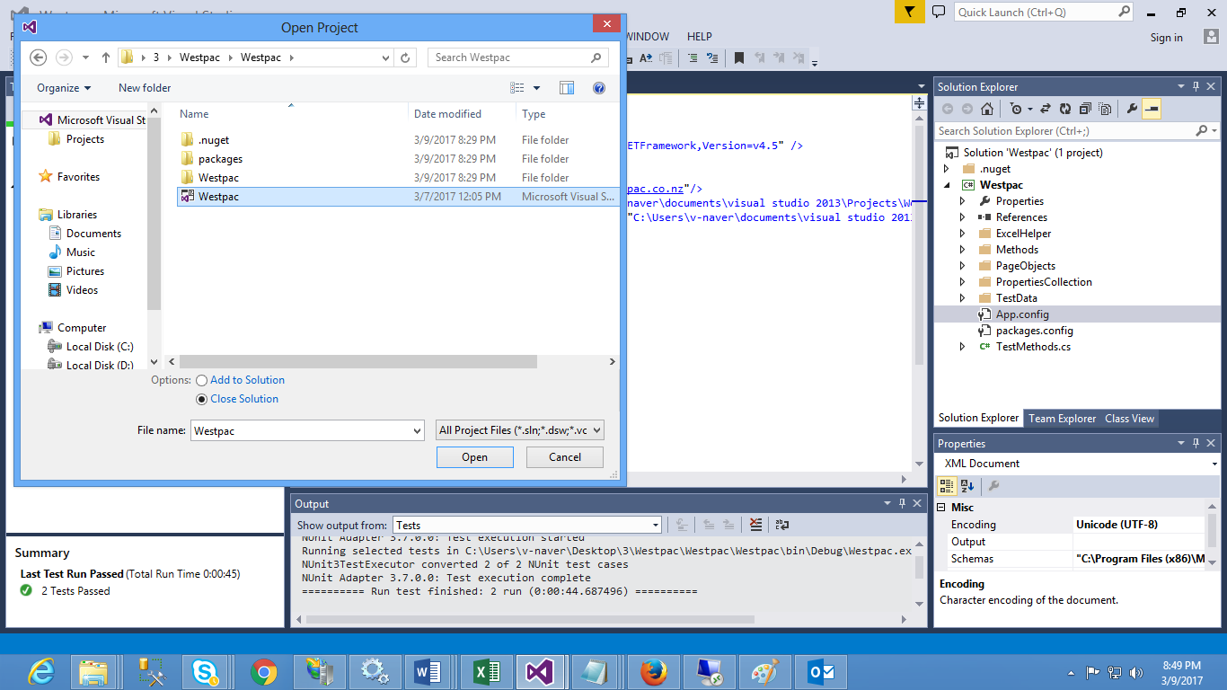

**Step 4: “InfoExcel.xlsx” and “Retirementcalculation.xlsx” will get copied inside the TestData folder within the project. We need to give the path of these two excels for “InfoExcel_Path” and “Retirementcalculation_Path” key values in App.config file**

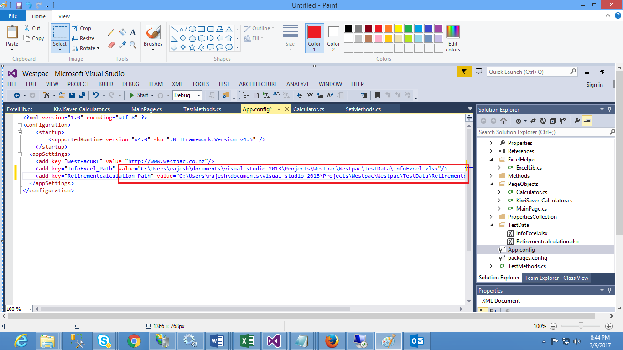

**Step 5: Go to the Build and click on Build Solution**

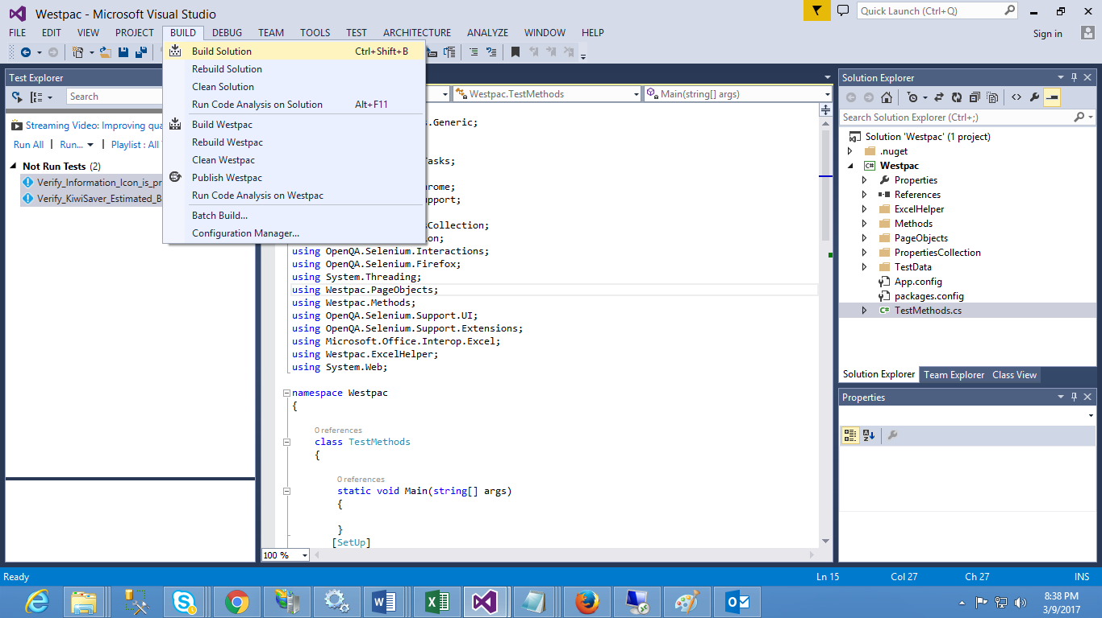

**Step 6: To run the tests, we need to go the Test Explorer and to achieve that follow the Navigation below.**

**Go to Test 🡪Right Click🡪Windows 🡪 Test Explorer (make a click).**

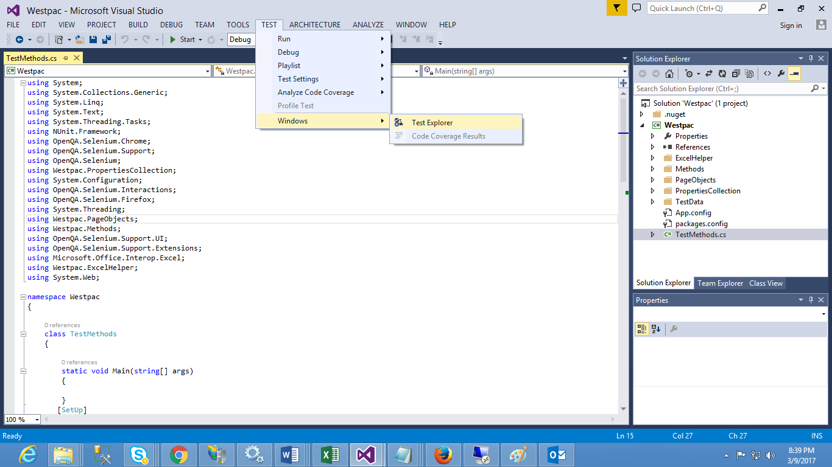

**Step 7: To the left side of the Visual Studio window we can see the Test Explorer with all the list of respective Test Methods.**

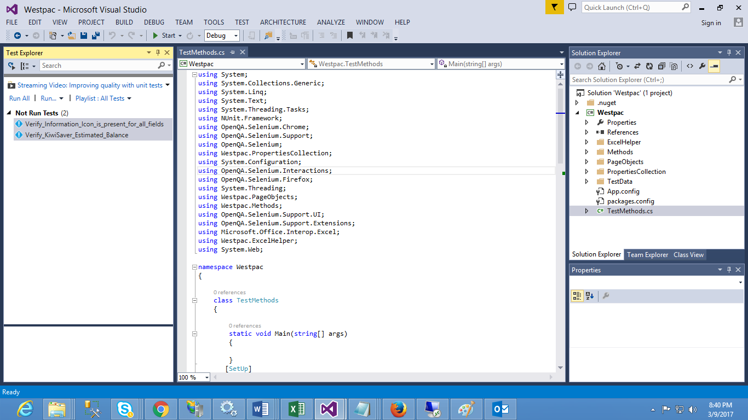

**Step 8:To run all the tests click on Run All option.**

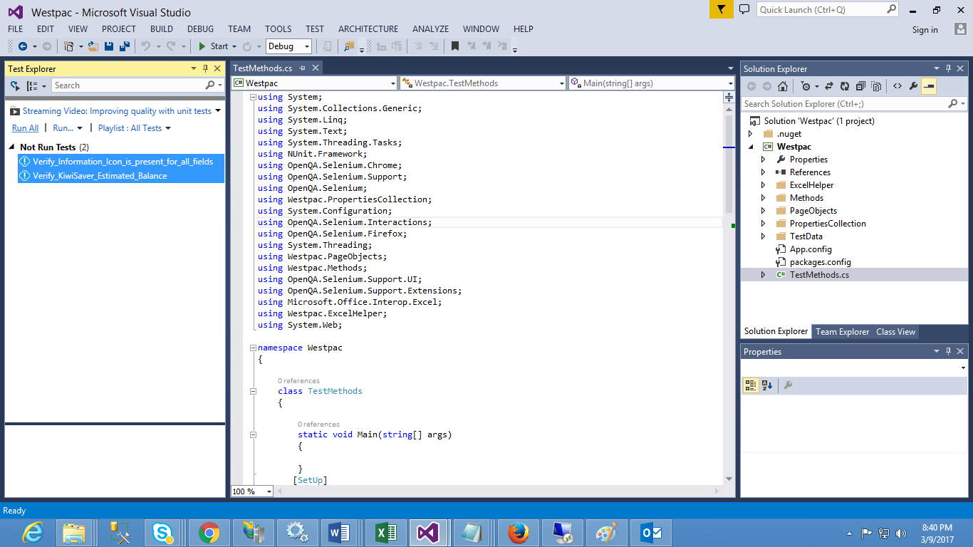

**Step 9: To run any one particular Test. Right click on that particular Test Method and click on the option Run Selected Tests.**

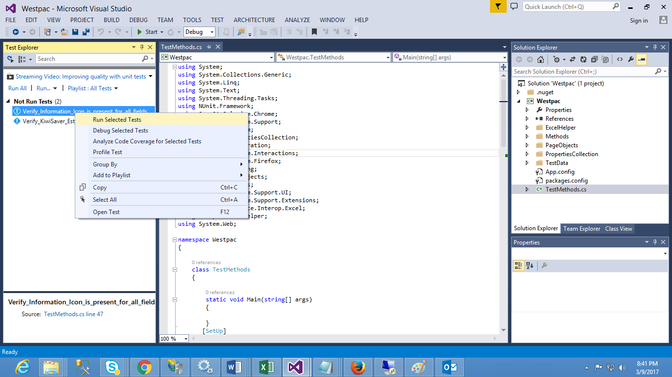

**Step 10: After execution of the Tests the results will be shown as**

